Chapter 7, Problem 1
What are the characteristics of the surface of a ductile fracture of a metal?

Chapter 7, Solution 1
A ductile fracture surface has a dull, fibrous appearance and often resembles a “cup-and-cone” configuration.

Chapter 7, Problem 2
Describe the three stages in the ductile fracture of a metal.

Chapter 7, Solution 2
The three stages consist of:

  - The specimen elongates, forming a necked region in which cavities form.
  - The cavities coalesce in the neck center, forming a crack which propagates toward the specimen surface in a direction perpendicular to the applied stress.
  - As the crack approaches the surface, its growth direction shifts to 45º with respect to the tension axis. This redirection allows for the formation of the cup-and-cone configuration and facilitates fracture.

Chapter 7, Problem 3
What are the characteristics of the surface of a brittle fracture of a metal?

Chapter 7, Solution 3
A brittle fracture surface typically appears shiny with flat facets which are created during cleavage fracture.

Chapter 7, Problem 4
Describe the three stages in the brittle fracture of a metal.

Chapter 7, Solution 4
The three stages of brittle fracture are:

  - As a result of plastic deformation, dislocations become concentrated along slip planes;
  - Shear stresses increase in areas where dislocations are impeded from movement. As a result, microcracks are nucleated.
  - Microcracks propagate as a result of further increases in shear stress. Stored elastic strain energy can also contribute to the propagation.

Chapter 7, Problem 5
What do chevron patterns indicate?

Chapter 7, Solution 5
Chevron patterns are typically found in brittle type fractures and they point to the origin (starting point) of the crack.

Chapter 7, Problem 6
Why are ductile fractures less frequent in practice than brittle fractures?

Chapter 7, Solution 6
Ductile fracture is less frequent because it is accompanied with excessive plastic deformation. Plastic deformation could easily be picked up through inspection and the part could be changed before complete failure.

Chapter 7, Problem 7
Differentiate between transgranular and intergranular fractures.

Chapter 7, Solution 7
In the intergranular type of fracture, the crack propagates along the grain boundary due to embrittlement through segregation of impurities. On the contrary, transgranular fracture refers to a situation where the crack propagates through the matrix of the grain (most brittle fractures are of this form).

Chapter 7, Problem 8
Describe the simple impact test that uses a Charpy V-notch sample.

Chapter 7, Solution 8
In the Charpy V-notch test, a heavy hammer attached to a pendulum is released from a known height, and during its downward swing, strikes and fractures a notched specimen. The energy absorbed by the specimen, a measure of toughness, is calculated based upon the change in potential energy of the pendulum.

Chapter 7, Problem 9
How does the carbon content of a plain-carbon steel affect the ductile-brittle transition temperature range?

Chapter 7, Solution 9
As the carbon content of the steel increases, the ductile-brittle transition temperature range increases in terms of both the width of the range and the temperature values.

Chapter 7, Problem 10
Describe a metal fatigue failure.

Chapter 7, Solution 10
Fatigue failure in a metal is caused by the application of repetitive or cyclic loading; the part, subjected to cyclic stressing, fails often at a stress value well below its normal limit.

Chapter 7, Problem 11
What two distinct types of surface areas are usually recognized on a fatigue failure surface?

Chapter 7, Solution 11
The two distinct types of surface areas typically observed on a fatigue failure surface are: a smooth region of “beach” marks created by rubbing action between the crack surface areas; and a rough region which is formed through the fracture process.

Chapter 7, Problem 12
Where do fatigue failures usually originate on a metal section?

Chapter 7, Solution 12
Fatigue failures typically originate at a point of high stress concentration, such as a sharp corner or notch.

Chapter 7, Problem 13
What is a fatigue test SN curve, and how are the data for the SN curve obtained?

Chapter 7, Solution 13
A fatigue test SN curve is a plot of the fatigue stress to which a specimen is subjected versus the corresponding cycles, or stress reversals, up to and including the point of failure. The number of cycles is plotted on a logarithmic scale while the fatigue strength is plotted on either a linear or logarithmic scale, depending on the data. The SN data is typically obtained by repeatedly subjecting a rotating specimen to reverse or fluctuating bending while counting the cycles until destruction occurs. However, specimens may also be subjected to reversed or fluctuating axial stresses, torsional stresses, or combined stresses in testing.

Chapter 7, Problem 14
How does the SN curve of a carbon steel differ from that of a high-strength aluminum alloy?

Chapter 7, Solution 14
In an SN curve for a carbon steel, the stress at failure levels off as the number of cycles exceeds the metal’s endurance limit of approximately 10⁶ cycles. Whereas the SN curve for a high strength aluminum alloy continues to gradually decrease as the number of cycles is increased above 10⁶.

Chapter 7, Problem 15
Describe the four basic structural changes that take place when a homogeneous ductile metal is caused to fail by fatigue under cyclic stresses.

Chapter 7, Solution 15
For a homogeneous ductile metal subjected to fatigue, four stages of structural changes are observed:

- Crack initiation: Plastic deformation causes the onset and early development of fatigue damage.
- Slipband crack growth (Stage I): Slipband intrusions and extrusions are created on the surface of the metal while damage along persistent slipbands occurs within the sample. As a result, cracks form at or near the surface and propagate along planes subjected to high shear stresses.
- Crack growth on planes of high tensile stress (Stage II): The slow crack growth of Stage I is replaced by rapid crack propagation as the crack direction shifts to a direction perpendicular to the direction of maximum tensile stress. During this stage, striations are formed.
- Ultimate ductile failure: The crack achieves an area sufficient to cause the rupture of the sample by ductile fracture.

Chapter 7, Problem 16
Describe the four major factors that affect the fatigue strength of a metal.

Chapter 7, Solution 16
The four primary factors which affect the fatigue strength of a metal are: stress concentration, surface roughness, surface condition and environment.

Chapter 7, Problem 17
What is metal creep?

Chapter 7, Solution 17
Creep of a metal refers to the slow, progressive plastic deformation of a metal subjected to a constant load or stress. Thus creep is the time dependent strain of a metal.

Chapter 7, Problem 18
For which environmental conditions is the creep of metals especially important industrially?

Chapter 7, Solution 18
Creep is of particular importance to industrial applications involving high stress and high temperature environments.

Chapter 7, Problem 19
Draw a typical creep curve for a metal under constant load and at a relatively high temperature, and indicate on it all three stages of creep.

Chapter 7, Solution 19

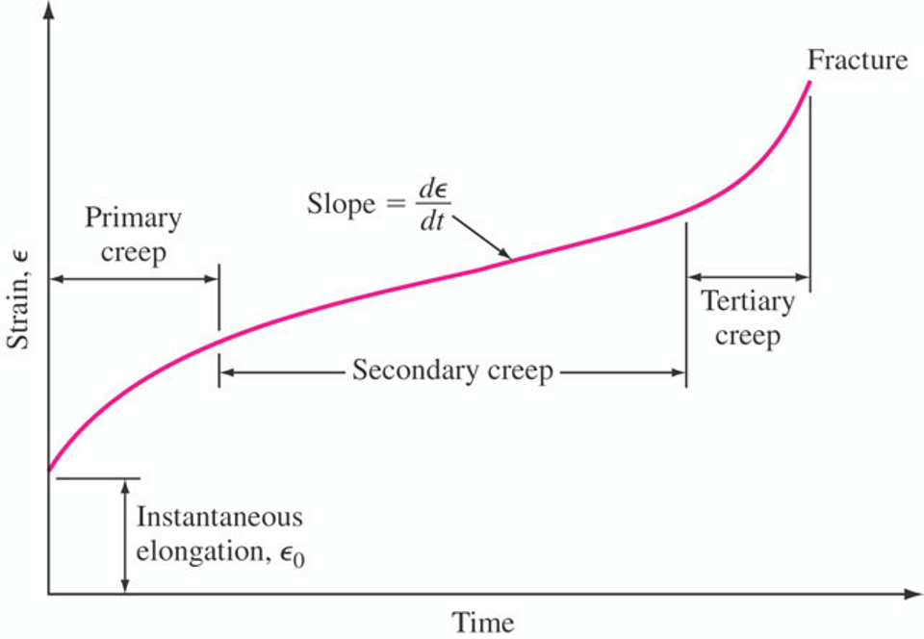

Chapter 7, Problem 20
Determine the critical crack length for a through crack contained within a thick plate of 7075-T751 aluminum alloy that is under uniaxial tension. For this alloy 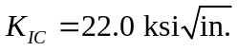 and σ_{f} = 82.0 ksi. Assume 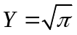.

Chapter 7, Solution 20

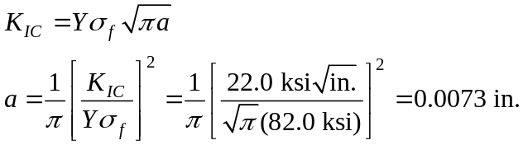

For an internal through crack, the critical length is a_{c} = 2a = 0.015 in.

Chapter 7, Problem 21
Determine the critical crack length for a through crack in a thick plate of 7150-T651 aluminum alloy that is in uniaxial tension. For this alloy 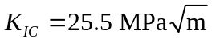and σ_{f} = 400 MPa. Assume .

Chapter 7, Solution 21

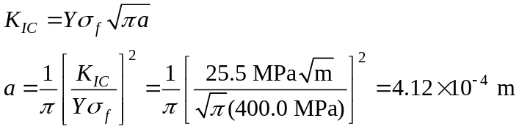

For an internal through crack, the critical length is a_{c} = 2a = 8.24 ×10⁻⁴ m = 0.824 mm.

Chapter 7, Problem 22
The critical stress intensity (K_{IC}) for a material for a component of a design is 23.0 ksi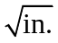 What is the applied stress that will cause fracture if the component contains an internal crack 0.13 in. long? Assume Y = 1.

Chapter 7, Solution 22

The applicable crack length is a = ½ a_{c} = (0.13 in.)/2 = 0.065 in. Substituting,

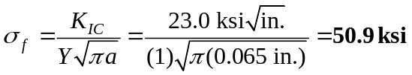

Chapter 7, Problem 23
What is the largest size (mm) internal through crack that a thick plate of aluminum alloy 7075-T651 can support at an applied stress of (a) three-quarters of the yield strength and (b) one-half of the yield strength? Assume Y = 1.

Chapter 7, Solution 23
What is the largest size (mm) internal through crack that a thick plate of aluminum alloy 7075-T651 can support at an applied stress of (a) three-quarters of the yield strength and (b) one-half of the yield strength? Assume Y = 1.

From Table 7.1, for 7075-T651,
- Given 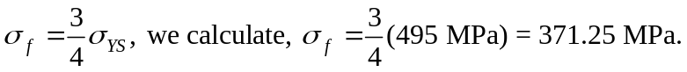 Assuming Y = 1, the crack length is,

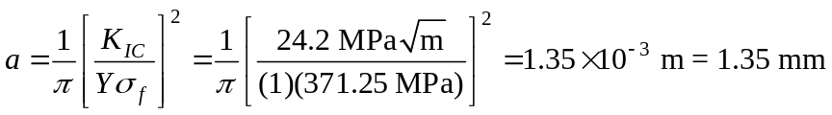

Thus, for an internal through crack, a_{c} = 2a = 2.70 mm

- Given 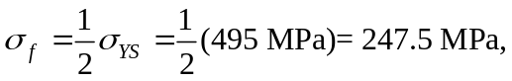 and assuming Y = 1,
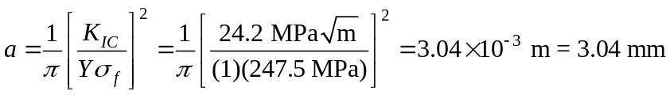

Thus, for an internal through crack, a_{c} = 2a = 6.08 mm.

Chapter 7, Problem 24
A Ti-6Al-4V alloy plate contains an internal through crack of 1.90 mm. What is the highest stress (MPa) that this material can withstand without catastrophic failure? Assume Y = 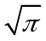.

Chapter 7, Solution 24
The applicable crack length is a = ½ a_{c} = (1.90 mm)/2 = 0.95 mm. And from Table 7.1,

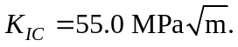 Substituting,

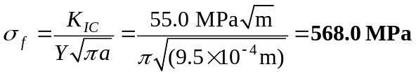

Chapter 7, Problem 25
Using the equation 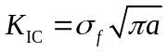, plot the fracture stress (MPa) for aluminum alloy 7075-T651 versus surface crack size a (mm) for a values from 0.2 mm to 2.0 mm. What is the minimum size surface crack that will cause catastrophic failure?

Chapter 7, Solution 25
In order to generate the required plot, we must first calculate the fracture stress for values of a ranging from 0.2 mm to 2.0 mm using the given relation:

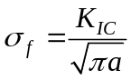 where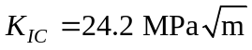based on Table 7.1. Substituting,
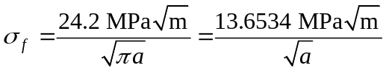

This relation is used to calculate and plot the following values of fracture stress versus crack size.

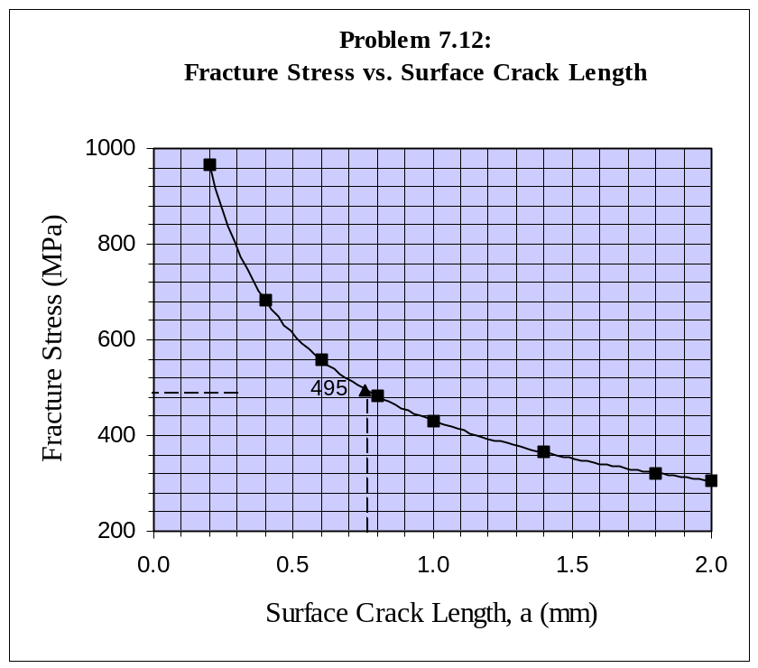
Crack Length, a  (mm) | Fracture Stress, 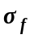 (MPa)
0.2 | 965.4
0.4 | 682.7
0.6 | 557.4
0.8 | 482.7
1.0 | 431.8
1.4 | 364.9
1.8 | 321.8
2.0 | 305.3

The minimum surface crack length, for catastrophic failure, would correspond to a fracture stress equal to the material’s yield stress value. Thus, from Table 7.1, 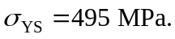 Substituting,

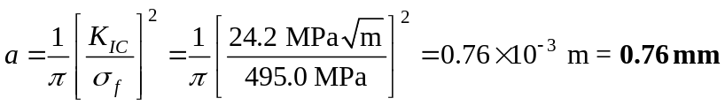

This point has been included in the plot generated for fracture stress vs. surface crack size. One may deduce that for crack lengths above the minima of 0.76 mm, the alloy will fracture catastrophically. Whereas, for values of a less than 0.76 mm, the alloy will yield and fracture at 495 MPa in the normal manner.

Chapter 7, Problem 26
Determine the critical crack length (mm) for a through crack in a thick 2024-T6 alloy plate that has a fracture toughness 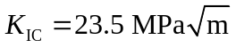 and is under a stress of 300 MPa. Assume Y = 1.

Chapter 7, Solution 26

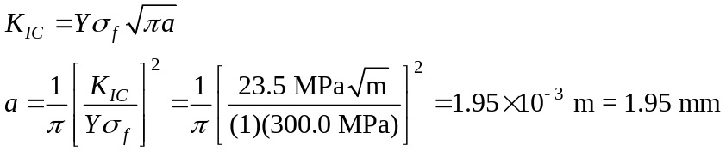

For an internal through crack, the critical length is a_{c} = 2a = 3.90 mm.

Chapter 7, Problem 27
A fatigue test is made with a maximum stress of 25 ksi (172 MPa) and a minimum stress of -4.00 ksi (-27.6 MPa). Calculate (a) the stress range, (b) the stress amplitude, (c) the mean stress, and (d) the stress ratio.

Chapter 7, Solution 27
- The range of stress is
- The stress amplitude is 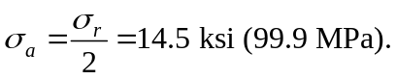
- The mean stress is 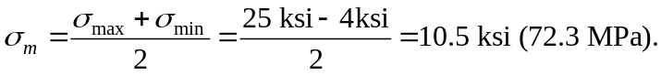
- The stress ratio is 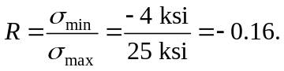

Chapter 7, Problem 28
A fatigue test is made with a mean stress of 17,500 psi (120 MPa) and a stress amplitude of 24,000 psi (165 MPa). Calculate (a) the maximum and minimum stresses, (b) the stress ratio, and (c) the stress range.

Chapter 7, Solution 28
Given

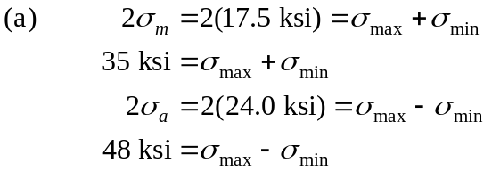

Adding these two equations and solving,

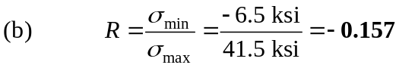

Chapter 7, Problem 29
A large flat plate is subjected to constant-amplitude uniaxial cyclic tensile and compressive stresses of 120 and 35 MPa, respectively. If before testing the largest surface crack is 1.00 mm and the plain-strain fracture toughness of the plate is 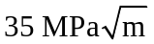, estimate the fatigue life of the plate in cycles to failure. For the plate, m = 3.5 and A = 5.0 × 10⁻¹² in MPa and meter units. Assume Y = 1.3.

Chapter 7, Solution 29
The final crack length, from the fracture toughness equation, is:

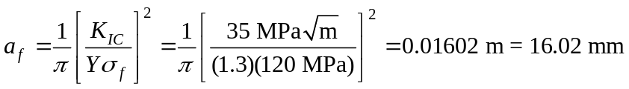

The fatigue life in cycles, N_{f} , is then,

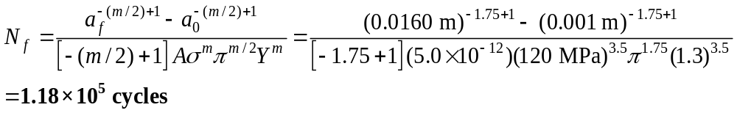

Chapter 7, Problem 30
Refer to Prob. 7.29: If the initial and critical crack lengths are 1.25 and 12 mm, respectively, in the plate and the fatigue life is 2.0 × 10⁶ cycles, calculate the maximum tensile stress in MPa that will produce this life. Assume m = 3.0 and A = 6.0 × 10⁻¹³ in MPa and m units. Assume Y = 1.20.

Chapter 7, Solution 30
The maximum tensile stress is calculated as:

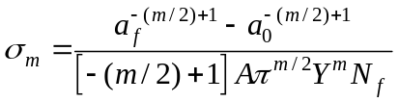
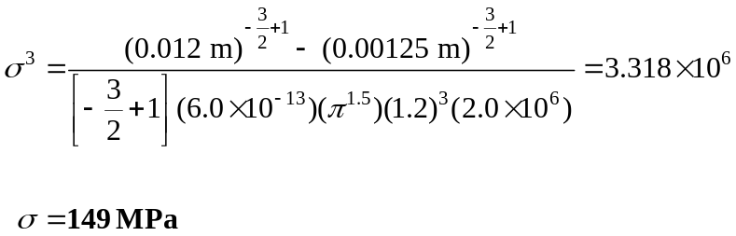

Chapter 7, Problem 31
Refer to Prob. 7.29: Compute the final critical surface crack length if the fatigue life must be a minimum of 7.0 × 10⁵ cycles. Assume the initial maximum edge surface crack length of 1.80 mm and a maximum tensile stress of 160 MPa. Assume m = 1.8 and A = 7.5 × 10⁻¹³ in MPa and meter units. Assume Y = 1.25.

Chapter 7, Solution 31
The final critical crack length can be using the equation for fatigue life,

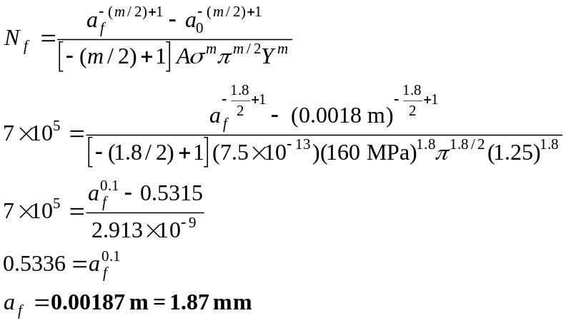

Chapter 7, Problem 32
Refer to Prob. 7.29: Compute critical surface edge crack if fatigue life must be 8.0 × 10⁶ cycles and maximum tensile stress is 21,000 psi. m = 3.5 and A = 4.0 × 10⁻¹¹ in ksi and in. units. Initial crack (edge) is 0.120 in. Y = 1.15.

Chapter 7, Solution 32
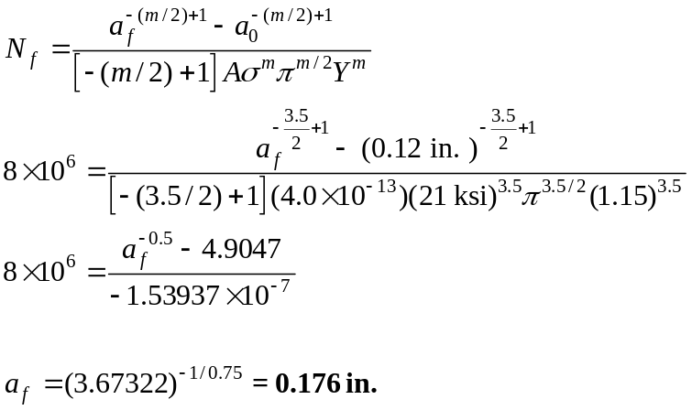

Chapter 7, Problem 33
The following creep data were obtained for a titanium alloy at 50 ksi and 400°C. Plot the creep strain versus time (hours) and determine the steady-state creep rate for these test conditions.

Strain (in./in.) | Time (h) | Strain (in./in.) | Time (h)
0.010 × 10⁻² | 2 | 0.075 × 10⁻² | 80
0.030 × 10⁻² | 18 | 0.090 × 10⁻² | 120
0.050 × 10⁻² | 40 | 0.11 × 10⁻² | 160

Chapter 7, Solution 33

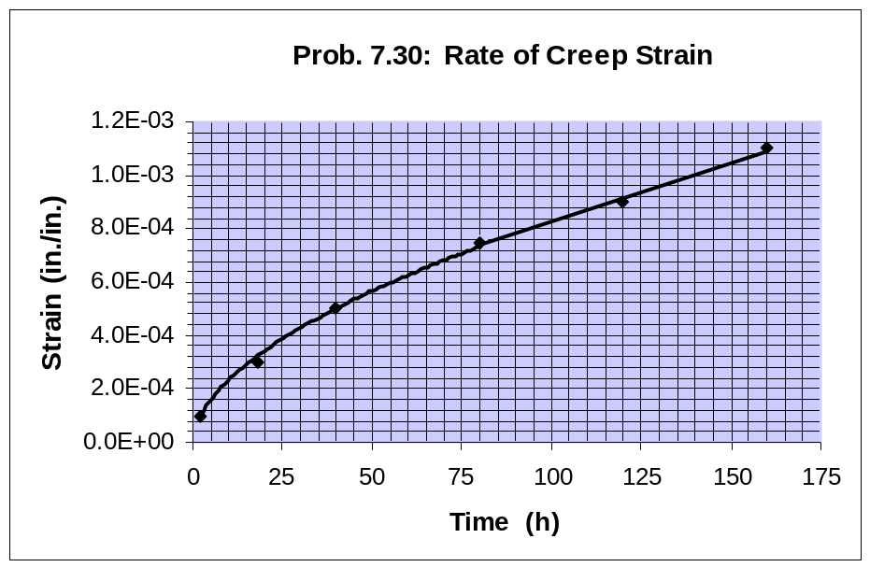

Chapter 7, Problem 34
Equiaxed MAR-M 247 alloy is to support a stress of 276 MPa (Fig. 7.31). Determine the time to stress rupture at 850°C.

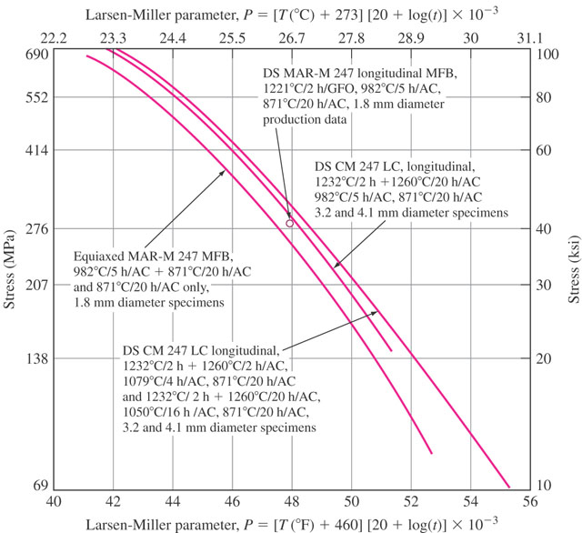

Figure 7.31

Chapter 7, Solution 34
From Fig. 7.31, for a stress of 276 MPa, the L.M. parameter value for Equiaxed MAR-M 247 is 26 × 10³ K·h. Thus,

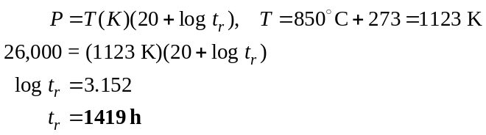

Chapter 7, Problem 35
DS MAR-M 247 alloy (Fig. 7.31) is used to support a stress of 207 MPa. At what temperature (°C) will the stress rupture lifetime be 210 h?

Figure 7.31

Chapter 7, Solution 35
From Fig. 7.31, for a stress of 207 MPa, the L.M. parameter value for DS MAR-M 247 alloy is 27.5 × 10³ K·h. Thus,

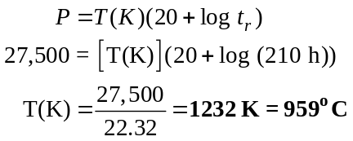

Chapter 7, Problem 36
If DS CM 247 LC alloy (middle graph of Fig. 7.31) is subjected to a temperature of 960°C for 3 years, what is the maximum stress that it can support without rupturing?

Figure 7.31

Chapter 7, Solution 36
Given ,

From Fig. 7.31, for P = 30.1 × 10³, the stress is approximately 96 MPa.

Chapter 7, Problem 37
A Ti–6Al–2Sn–4Zr–6Mo alloy is subjected to a stress of 20,000 psi. How long can the alloy be used under this stress at 500°C so that no more than 0.2% creep strain will occur? Use Fig. 7.32.
Chapter 7, Solution 37
From Fig. 7.32, for a stress of 20 ksi, the L.M. parameter for 2% stress is P ≈ 31,000. Thus,

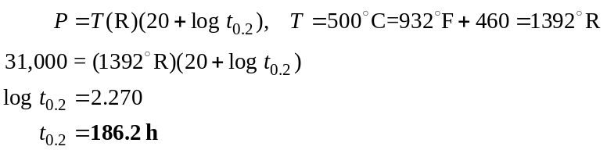

Chapter 7, Problem 38
Gamma titanium aluminide is subjected to a stress of 50,000 psi. If the material is to be limited to 0.2% creep strain, how long can this material be used at 1100°F? Use Fig. 7.32.
Chapter 7, Solution 38
From Fig. 7.32, for a stress of 50 ksi, the L.M. parameter for 2% stress is P ≈ 36,600. Thus,

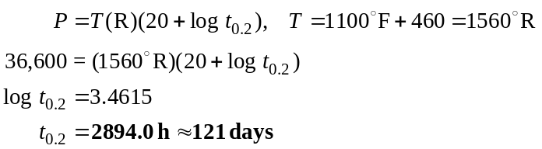

Chapter 7, Problem 39
A Charpy V-notch specimen is tested by the impact-testing machine in Fig. 7.9. In the test, the 15 kg hammer of arm-length 120 cm (measured from the fulcrum to the point of impact) is raised to 90° and then released. (a) What is the potential energy stored in the mass at this point? (b) After fracture of the specimen, the hammer swings to 45°. What is the potential energy at this point? (c) How much energy was expended in the fracture of the specimen? Hint: potential energy _ mass _ g _ height.

Chapter 7, Solution 39
a)
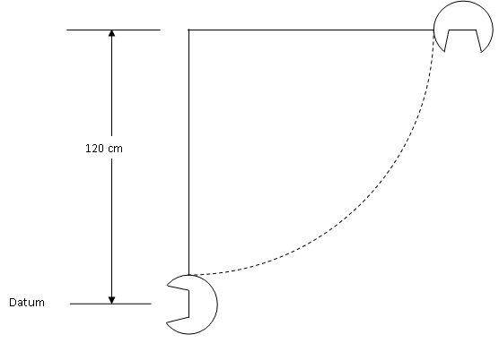

g = 9.81 m/s2
m = 15 kg
h = 120 cm
V = mgh
= 176.6 J

b)
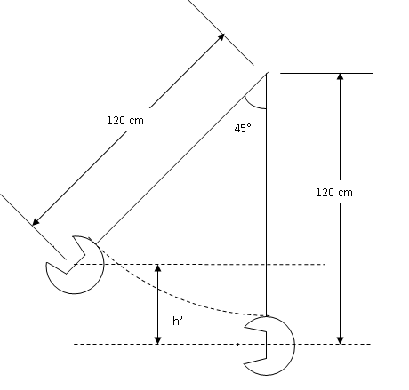
After impact θ=45°
V _{θ=45} = mgh’
h’ = h – l cos45 = 120 (1 – cos45)
h’ = 35.147 cm
V _{θ=45} = (15kg) (9.81m/s²) (0.57m)
V _{θ=45} = 51.50 J
Energy lost during impact = 176.6 – 83.9 = 125.1 J
(toughness of the specimen)

Chapter 7, Problem 40
Assuming that the maximum angle the pendulum in problem 43 can rise to is 120° and if the V-notch specimen requires 220 J of energy for fracture, will the above system have sufficient capacity to achieve the fracture of the specimen? How much will the pendulum rise if it achieves fracture of the specimen?
Chapter 7, Solution 40

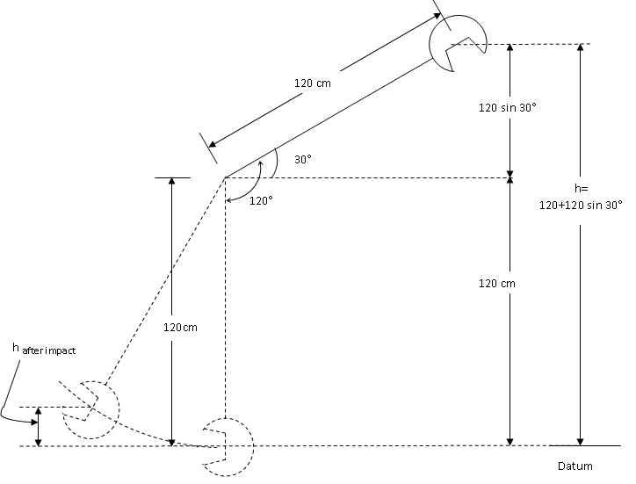
V = mgh = (15kg) (9.81) (120+60)/100
V = mgh = (15kg) (9.81 m/s²) (1.8m) = 264.8 J
- The potential energy of 264.8 J is greater than 280 J required for fracture. Specimen will break.
- ∆V = 264.8 – 220 = 44.8J
44.8 = mgh = (15kg)(9.81)(h)
⇒ 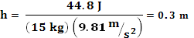 = 30cm
Chapter 7, Problem 41
The circumferential stress, s, (also called hoop stress) in a pressurized cylindrical vessel is calculated by the equation s _ Pr/t, where P is the internal pressure, r is radius of the vessel, and t its thickness. For a vessel of 36 in diameter, 0.25 in thickness and an internal pressure of 5000 psi, what would be the critical crack length if the vessel were made of (a) Al 7178-T651, (b) alloy steel (17-7 pH)?
What is your conclusion? Use Table 6.1 for properties. (Use Y _ 1.0 and assume center crack geometry.)

Chapter 7, Solution 41
σ
σ
P
t
r

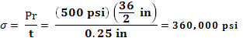
(note a pressure of about 5000 psi creates a large hoop stress)
- If made of Al:
for Al 7078 T651
21,000 psi √in = (1.0)(360,000 psi)
⇒ = 0.058 ⇒ a = 0.0011”
Crack length = 2a = 0.0022”
- If made of 17-7 pH alloy steel:
70,000 psi √in = (1.0)(360,000 psi)
⇒ = 0.19 ⇒ a = 0.012”
Crack length = 2a = 0.024”
Conclusion: using 17-7 pH alloy steel will allow us to tolerate significantly larger cracks.

Chapter 7, Problem 42
For the vessel in problem 7.41, consider that it is made of Titanium alloy (Ti-6Al-4V). (a) If cracks of length a_0.005 inch are detected in the vessel, what should the safe operating pressure be? What if cracks of length a_0.2 inches are detected, what should the safe operating pressure be? Use Y_1.0 and assume center crack geometry.

Chapter 7, Solution 42
- a = 0.005 in ( a is half crack length)
⇒ 50,000 psi √in = (1.0) σ
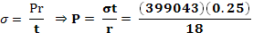
⇒ P = 5542 psi (maximum operating pressure)
- a= 0.2 in (a is half crack length)
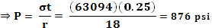
Note that maximum operating pressure drops significantly with increase in crack length.

Chapter 7, Problem 43
An ultrasonic crack detection equipment used by Company A can find cracks of length a _ 0.25 inches and longer. A lightweight component is to be designed and manufactured and then inspected for cracks using the above machine. The maximum uniaxial stress applied to the component will be 60 ksi. Your choices of metals for the component are Al 7178 T651, Ti-6Al-4V, or 4340 steel as listed in Table 7.1. (a) Which metal would you select to make the component from? (b) Which metal would you choose when considering both safety and weight? (Use Y_1.0 and assume center crack geometry.)

Chapter 7, Solution 43
Cracks of a = 0.2” can be detected (half crack length)
σ =60 ksi
Al 7178 T651
Ti – 6Al – 4V
4340 steel

- Al: 21,000 = (1.0) (60,000) ⇒ a = 0.039”
Ti: 50,000 = (1.0) (60,000) ⇒ a = 0.22”
Steel: 55,000 = (1.0) (60,000) ⇒ a = 0.27”
The critical crack length for aluminum is much smaller than what the machine can detect. Reject the aluminum alloy as a choice.
The critical crack length for both Ti & steel alloys are larger than the length that the machine can detect. Either alloy will be acceptable but steel is safer.

- Considering both safety and weight, Ti alloy is the best choice since it has a lower density.

Chapter 7, Problem 44
In problem 7.43, if you did not consider the existence of cracks at all and only considered yielding under uniaxial stress as a failure criterion, (a) which metal would you select to avoid yielding? (b) Which metal would you select to avoid yielding and have the lightest component? (Use data in Table 7.1)? Is it a safe design practice to assume that no initial cracks exist? Explain.

Chapter 7, Solution 44

σ = 60 ksi
Al 7178 T651 σ_{Y} = 83 ksi
Ti – 6Al – 4V σ_{Y} = 150 ksi
4340 steel σ_{Y} = 220 ksi
- The applied uniaxial stress is lower than the yield strength of all metals. Thus, any of the three metals would work.
- Al alloy would be a good alloy since its yield strength is considerably higher than the applied stress but has a lower density than steel.
- In problem, 7.43, we should note that the aluminum alloy will not be a good choice if you consider pre-existing cracks. Thus it is not a safe practice to assume that no cracks exist in the material. It will always be safer to assume that cracks of certain length exist.

Chapter 7, Problem 45
It is a common practice in inspection of bridges (and other structures) that if a crack is found in the steel, the engineers will drill a small hole just ahead of the crack tip. How will this help?

Chapter 7, Solution 45

σ_{CT}
σ_{CT}
σ₀
σ₀
σ_{CT} > σ₀

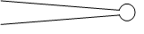

Crack with a hole drilled at its tip

Original crack
The tip of the crack is very sharp. The stresses at the sharp tip become amplified to levels many times larger than the far-field stress. This will cause the crack to propagate.
If a hole drilled at the crack tip, this will reduce the sharpness of the tip and will lower the state of stresses. The existing crack will not propagate.
It is important to note that cracks of certain length (below critical length) are tolerable with appropriate factor of safety.

Chapter 7, Problem 46
An alloy steel plate is subjected to a tensile stress of 120 Mpa. The fracture toughness of the materials is given to be 45 Mpa.m1/2. (a) Determine the critical crack length to assure the plate will not fail under the static loading conditions (assume Y_1). (b) Consider the same plate under the action of cyclic tensile/compressive stresses of 120 Mpa and 30 Mpa respectively. Under the cyclic conditions, a crack length reaching 50% of the critical crack length under static conditions (part a) would be
considered unacceptable. If the component is to remain safe for 3 million cycles,
what is largest allowable initial crack length?

Chapter 7, Problem 46
⇒ a = 0.044 m = 4.4 cm
“a” must be less than 0.044 m for component to be safe at the given stress level.
- (follow example 7.2)
a_{f} = final crack length = 0.5 (0.044) = 0.022 m

a_{f} = 0.022 m a₀= ? cycles
assume A = m = 3 Y=1
σ_{y} = 120-0 (compressive stresses are ignored)
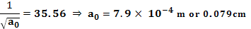
If initial cracks are longer than, the component will have a life shorter than cycles.

Chapter 7, Problem 47
A cylindrical rod made of directionally solidified alloy CM 247 is to carry a 10,000 N load at a temperature of 900° C and for a period of 300 hours. Using the Larson-Miller plot in Fig. 7.32, design the appropriate dimensions for the cross section.

Chapter 7, Solution 47

Larsen miller parameter
P = T (k) (20+log tr)
T°K = 900°C + 273 = 1173°K
t_{r} = 300 hrs
P = 1173 (20 + log 300) = 26365
= 26.3
Refer to figure 7.31, upper most graph. Enter with of 26.3 (top axis) and find the corresponding σ.
F = 10,000 N σ = 350 MPa
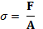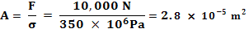
A = 0.28 cm²
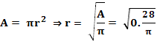
r = 0.30 cm

Chapter 7, Problem 48
In the manufacturing of connecting rods, 4340 alloy steel heat treatable to 260 Ksi may be used. There are two options for the manufacturing of the component, (i) heat treat the component and use, and (ii) heat treat and ground the surface. Which option would you use and why?

Chapter 7, Solution 48

The component must have an excellent fatigue life. All factors to improve fatigue life must be considered. If the surface is improved through grinding process (smooth surface), the fatigue life will improve.

Chapter 7, Problem 49
In aircraft applications, aluminum panels are riveted together through holes drilled in the sheets. It is the industry practice to plastically expand the holes to the desired diameter at room temperature (this introduces compressive stresses on the circumference of the hole). (a) Explain why this process is done and how it benefits the structure. (b) Design a system that would accomplish the cold expansion process effectively and cheaply. (c) What are some precautions that must be taken during the cold expansion process?

Chapter 7, Solution 49
- Introducing compressive residual stresses around a hole will improve its fatigue performance by reducing tensile stresses.

σ
σ
σ_{c}
σ_{c}
σ_{c}
σ_{c}

- Assume a compressive stress of 100MPa around the hole
σc = 100MPa σ = 100MPa

σc = 100MPa σ = 100MPa

- Add to it the externally applies stress of 100MPa in tension (ignore stress concentration effect).
- The point around the hold will be stress free. If there is not initial compressive stress, the stress around the hold will be 100MPa tensile.

dm
mandrel
∆t
dh

dm = d_{mandrel}
dh = d_{hole}
dm > dh
Force a mandrel of diameter dm through the hole of diameter dh. Since dm > dh, the hole will expand.
- Care must be taken not to overdo the cold expansion. This could cause micro cracks that would be detrimental.

Chapter 7, Problem 50
What factors would you consider in selecting materials for coins? Suggest materials for this application.

Chapter 7, Solution 50
- The metals should have the capacity to be formed with intricate patterns at room temperature (coining process).
- The metals should have reasonable strength and durability
- The metals should resist corrosion
- The amount of metal used in the coin should be less in value than the value of the coin itself.

Penny : 3% Copper, 97% Zinc
Nickel : 75% Copper, 25% Nickel
Dime : 91% Copper, 9% Nickel
Quarter : 91% Copper, 9% Nickel
Dollar (coin) : 88% Copper, 6% Manganese, 3% Zinc, 3% Nickel

Chapter 7, Problem 51
If you had a choice between an aluminum alloy, stainless steel, a plain low carbon steel alloy, and a plain high carbon steel alloy (all of which offer appropriate strength for the application) for a structural application in the Arctic regions which would you choose? Why? (Cost is not an issue.)

Chapter 7, Solution 51

The material selected should have a ductile-to-brittle (DBT) transition temperature that is significantly lower than the operating temperature. Not withstanding factors such as heat treatment and processing, the composition and structure are important considerations (strength is not an issue). FCC metals do not undergo DBT. Thus aluninum alloys are good candidates (figure 7.10). High carbon content willl increase DBT and this is dangerous (figure 7.11). Stainless steel, due to its low carbon content will also be a good choice.

Chapter 7, Problem 52
Examine the fracture surface of a fractured steel tube. How would you classify this fracture? Can you tell where the fracture started from? How?

Chapter 7, Solution 52

This fracture is brittle fracture formed due to existence of a defect at the bottom of the tube. The chevron patterns radiating from the defect are signature of brittle type fractures. These patterns point to the origin of fracture

Chevron Patterns
defect

The defect could be an includion, porosity, tiny cracks etc.

Chapter 7, Problem 53
Examine the fracture surfaces below and discuss the differences in surface features. Can you identify the type and nature of the fracture?

Chapter 7, Solution 53

Figure P7.53 a shows equiaxed dimpled surface similar to that in figure 7.3. This is generally indicative of ductile fracture.
Figure P7.53 b shows brittle cleavage fracture in which grain fracture along specific slip planes (similar to figure 7.7). The fracture is transgranular.
Figure P7.53 c shows intergranular brittle fracture. Note that the grains are clearly distinguishable and plastic deformation is not observed.

Chapter 7, Problem 54
The components in Fig. P7.54 is high strength steel racecar transmission shaft, which is cyclically loaded in torsion and some bending. The one at the bottom of Fig. P7.54a is fractured. Figure P7.54b shows a higher magnification image of the fracture path around the shaft. Figure P7.54c shows that cross-section of the fractured shaft. Based on this visual evidence speculate as much as possible about what happened to this shaft and where

Chapter 7, Solution 54

Examination of figure P7.54 b shows that the shaft was indented to place the date of manufacturing on it. If you look closely, you will notice that the crack runs through the number “0” indented on the shaft.
Examination of figure P7.54 c shows the initiation point on the left side of the shaft. This region corrresponds to the location of the “0” indentation on the shaft.

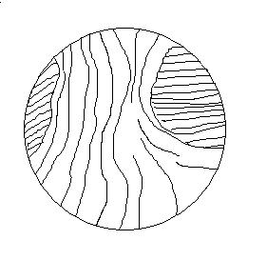
Final rupture fast
Crack propagation
beach marks
Slow Crack propagation
initiation point

The beach marks are clearly observed indicating step-wise crack propagation.
Once the crack propagates to a significant fraction of the area, the remaining intact section fractures catastrophically (final rupture).
Thus the cause of fracture was the indentaion of the shaft which slowly grew into a large crack due to cyclic torsion and bending.

